GAME DESIGN Report C17870 TRUMP ESCAPE/ LAND OF THE FREE THOMAS SIMMONS K1906250

Module Leaders: Hope Caton & Jarek Francik

Introduction 3

Ideas: 3

Aims: 3

Game origins: 4

Iterated version: 4

Inspiration 5

Tom Clancy - games storytelling: 5

Farming simulator customisation 5

GTA V customisation options 6

HALO 3 ODST discovery system 6

NFS Carbon territory gaining and rewards: 7

Recent political events 7

Starting points 7

Evolution/ Development 8

Interim Presentation 8

Progression Chart development 9

Game Icons: 10

Game Logos: 11

Title Logos: 11

Faction Logos: 11

Game Map and Features 12

Map 12

City Representation 12

Artefact: 13

Characters 15

Prototype 16

Future Development 17

Outcome 18

Conclusion 18

References 19

# Introduction

This report describes the origins and development the game, Trump Escape / Land of the Free, which at its core is a 3rd person role playing game whilst still being a game for every category of player. The four main categories of player fun are, ‘hard’, who are after personal goals and achievements, ‘serious’, who are after excitement, ‘easy’, who are after curiosity and surprise and ‘people’, who are after amusement **(link 1)**.

Whilst it is difficult to include all these types of players into one game successfully, one of the design aims of the game was to include the objectives of; achieving goals and strategy for ‘hard’ fun players, exploration and creativity for ‘easy’ fun players, collection and repetition for ‘serious’ fun players and completion for ‘people’ fun players **(Link 1).**

The following sections include descriptions of, the origin and development of the game idea, how its creation was inspired by world events, the mechanics implemented from previous games, the evolution of the current game build and how this was achieved, the outcome of the most recent build and finally the future development ideas. **(Link 2**).

Whilst the main aim was to create a game for everyone to enjoy, there was also a lot of personal interest in the idea of a strategic game based on American politics, and what could happen. As the characters have been based on real people, their achievements and how they have disappointed or inspired people, has been included in their back stories, in order to make the game more realistic.

# Ideas:

The original idea was for a game based on current American politics, especially the actions of Donald Trump during the 2016 campaign and beyond as these generated a lot of worldwide interest, this and other events has increased interest in politics which makes for a great unique game genre.

In preparation, research was conducted into the main news stories around the period leading up to the 2016 USA elections and beyond, and how Trump in particular has effected the world view of US politics, and the consequential changes in approach of other major political personalities.

The player will have a choice of being Donald Trump, a Hillary Clinton activist, or Barak Obama, in a game world depicting a fictional, but plausible, decline of America into a politically motivated civil war. The aim will of the game is to retake or maintain power in America and destroy your opponents, from one of three starting points depending on which main character is selected.

# Aims:

The target age group for this game is 16 plus, due to the high level of violence, moderate use of bad language, references to discrimination and drug usage. However due to the characters involved, the theme and fantasy storyline, the game shouldn’t be rated 18.

The target market is thus players of all categories, **(Link 1),** be they**;** “people players”, who are into communication with allies and enemies who also love to complete games, “hard players”, who are into achievements and strategic gameplay, “easy players” who are creative and enjoy exploring worlds, or “serious players” who like levels of difficulty, collecting things, and the ability to replay in order to improve they score.

Thus the aim is to create a game based on a realistic storyline, with features and characters suitable for all player categories, which whilst difficult is possible by including features that; require skill and challenge for hard players, deliver expectation and storyline for easy players, supply relaxation and excitement for serious players, and collaborative playing for people players. Which will make this game attractive to all of them.

# Game origins:

The origins of Trump Escape go back to a two player board game called Hnefatafl **(link 3),** better known as Tablut **(Link 4)** which is a Viking game from the early medieval period. The board was made up of 11x11 squares, figure 1, with one attacking player having twenty four pieces and the defender having twelve to protect a king, the rules of the game are below:

* Aim of the player with twenty four pieces is to capture the king
* Aim of the player with twelve pieces is to help the king reach a corner of the board
* Movement is one square horizontally or vertically, no diagonal
* No piece can rest on the refuge or kings’ starting squares
* Pieces are removed if they are squashed between two of the oppositions pieces
* If a legal move cannot be taken on their turn the game is a draw
* To capture the king he has to be surrounded on all four sides so is unable to move
* Win conditions are; the king is captured or escapes by reaching the corner of the board.

## Iterated version:

In a past assignment an iteration of this game was developed to improve gameplay by keeping the players engaged whilst preventing any dominant strategy making the game one sided. Several new rules were added and the board layout modified, as shown in figure 2:

* In the grey boundary on the board the king can move two spaces or one space diagonally
* Redesigned for 2-5 players, with 1 defender and up to four attackers
* Pieces can be captured and repositioned in red zones or killed and removed from the board
* If captured the alliance of a piece can then be changed giving control to another player
* Increased escape zones for the king to counter the numeric advantage of the attackers
* In 3-5 player mode the attacking players can work together, by themselves, in alliance with the defender, or against each other.

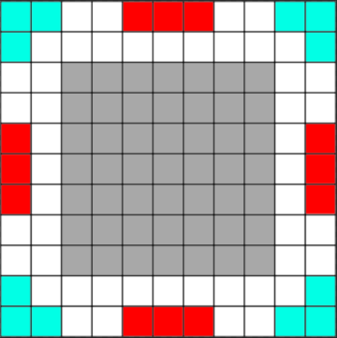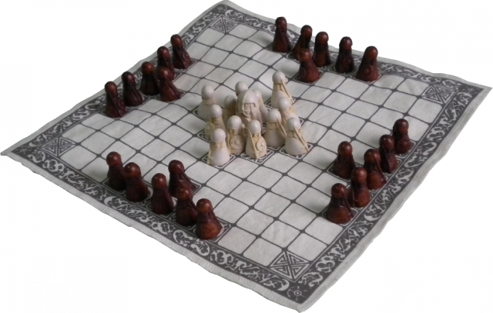With these new rules the players were far more engaged and lots of alliances, rivalries and strategies including ‘back stabbing’ were observed. Which is where the concept of a politically motivated game came from, specifically the America 2016 elections between Trump, Clinton, Sanders and other minor candidates **(link 5),** and the concepts for “Trump Escape” began to take form.

Figure Hnefatafl Board

Figure my iterations board

# Inspiration

During the development of Trump Escape, many game reviews were researched, and it soon became clear that few games received good reviews from everyone, thus the idea of incorporating the best aspects from each game and its genre, to create a game for every type of player was conceived.

## Tom Clancy - games storytelling:

Three of the most popular Tom Clancy games are; Ghost Recon, The Division & Rainbow and The Division, the reviews for which cite the storyline and gameplay as being the best part of this series.

With the exception of the Rainbow series these games are 3rd person, where the player is either alone playing as a super soldier saving America from civil war in The Division, or in a group of four trying to take down drug cartels or dictators in Ghost Recon.

These stories are thus vast and lengthy and if the player is engaged can be kept playing for long periods of time. To achieve this both game series have side missions and activities that players can complete for extra rewards and experience to level up there character.

Some of these missions relate to the main story, some are given to the player through discovery or free roam and others are earned by completing missions or tasks set by allies.

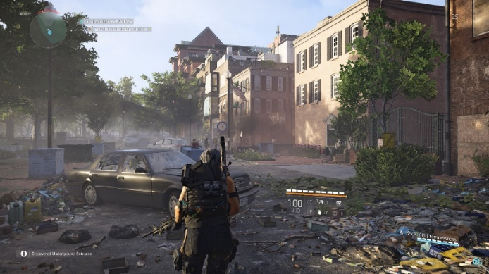All of which is designed to keep the players engaged with the game as well as the storyline.

Figure Player view

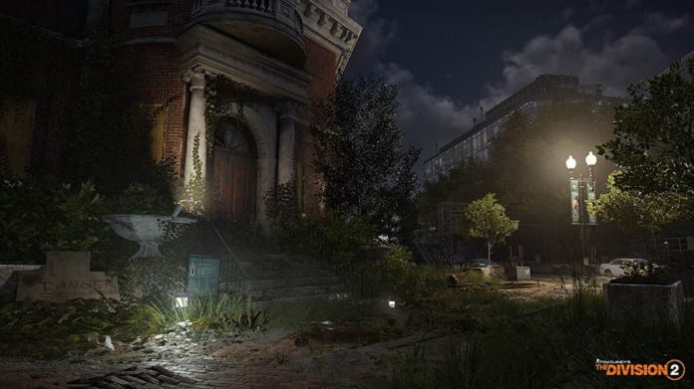Figures 3 & 4 depict the scenery and player view from Division 2 **(Link 6).**

Figure Scenery

## Farming simulator customisation

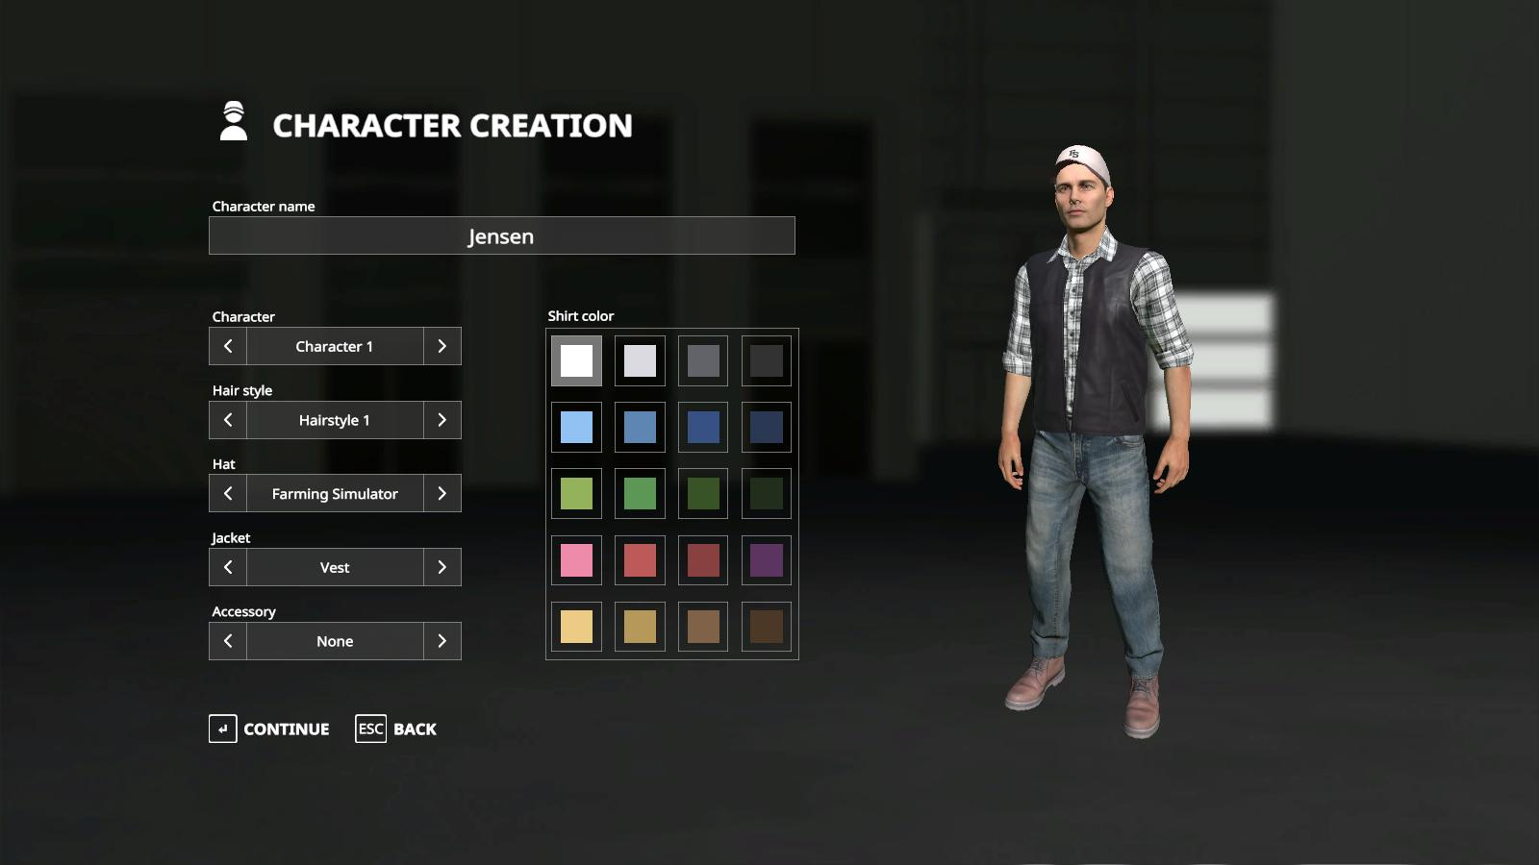This game has been a major hit with players around the world, due to its simplicity, relaxing influence and the requirement to use management skills. The feature that was most influential on Trump Escape was the simple and clear process to change the characteristics of an avatar. **(Link 7).**

Figure Option to select and customise character

## GTA V customisation options

This game has had extremely high reviews from players of all kinds due to its gameplay, story, customisation and open world features such as killing anything and anyone such as police, soldiers and the public. There’s also a lot of drug related crime in this game which may encourages players to engage in these actions safely rather than getting in trouble in the real world.

The two feature from this series that stand out are the free roam features **(Link 8)** and high character customisation options for the player **(Link 9).**

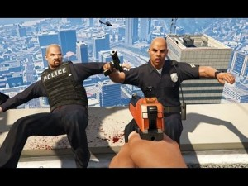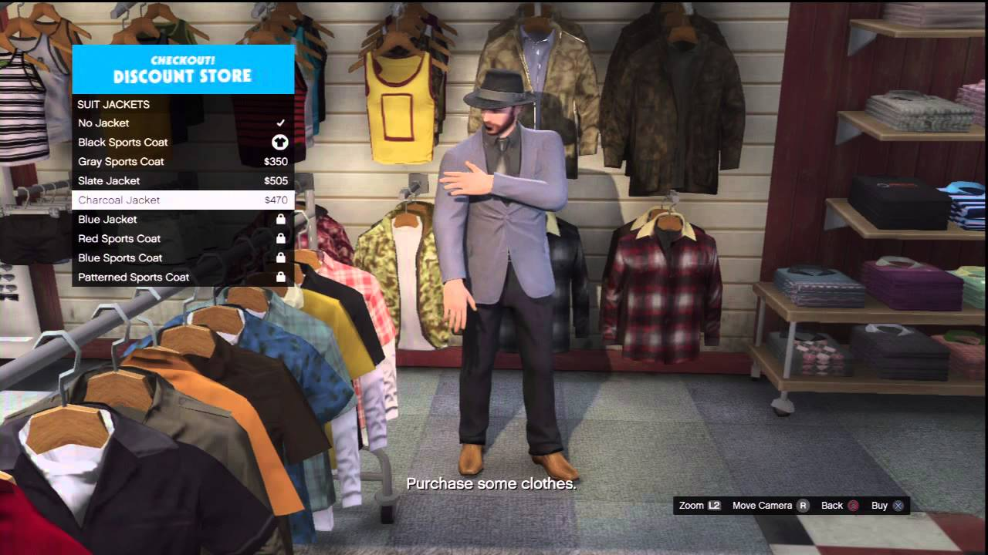Replicating this in Trump Escape, will allow players to create highly detailed characters, or if they wish just make their character look funny, and for those who are less interested in the storyline and just want some escapism, the free roam features will allow those players to go out and kill “stuff” animals, people or police just because they can. This is shown in figures 6 & 7 below.

Figure Random killing

Figure Detailed customisation

## HALO 3 ODST discovery system

Halo 3 ODST from the Halo series is based on a human alien war in the 26th century. The ODST (Orbital Shock Drop Trooper) spin off from Halo 3 has varied the game so the player is a human rather than a Spartan super soldier. The idea of this was to make players feel more vulnerable as enemy forces are far superior, thus requiring players to be more strategic during gameplay.

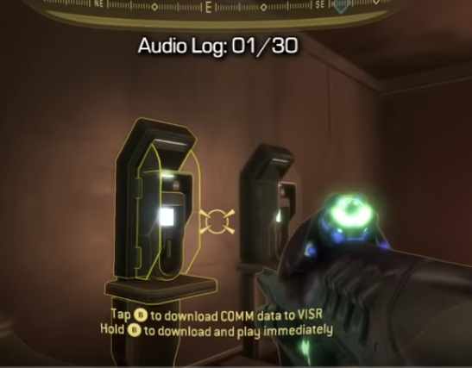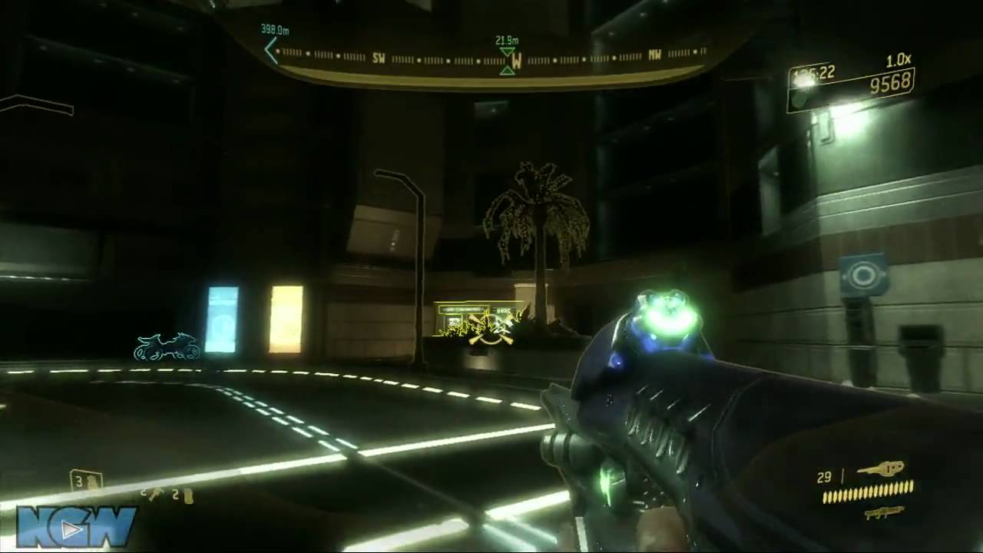How players discover collectables in this game, has influenced the similar feature in Trump Escape, with a distinct clear colour block, indicating the objects location, as well as an audible ringing which gets louder and clearer as the player gets closer, and vice versa as they move further away, **(Link 10),** Examples of this are shown in figures 8 and 9

Figure Audio indicator

Figure Colour indicators

## NFS Carbon territory gaining and rewards:

Need For Speed Carbon is a racing game where the player has to complete races of different kinds and by winning the majority of those races they capture the territory in question, along with extra rewards such as cars, visuals and respect. As they win more territories or zones and eventually capture them all the boss/ leader challenges the player to a series of races to win total control, after which they move onto the next area and so on.

However, this works both ways in that other minor factions as well as the main factions can win races in a zone already completed and capturing the territory which removes the rewards previously earned by the player.

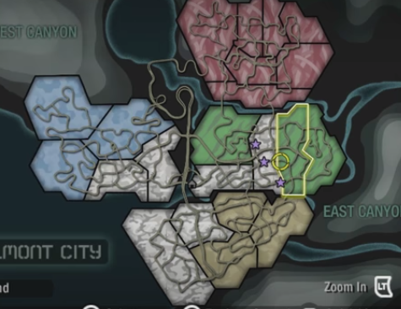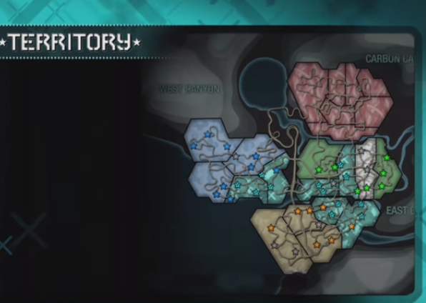This system explanation is shown on figures 10 & 11 between 18:44 to 19:10 (**Link 11)**

Figure territory capturing

Figure territory missions

The element to replicate from this game is the zone, territory capture system, replacing it with towns, regions and states with activities and side missions the player will need to complete.

Also replicating the risk of completed zones being won back by others, is an element that will work well in Trump Escape, as preventing the loss of territory already won will require strategy, otherwise it will become a distraction and prevent the successful completion of the game.

## Recent political events

One of the main inspirations to create this game has been the American political situation, which since the 2016 election, has been in the news almost daily, with never before seen Tweets from a president, with accusations and counter accusations on all sorts of subjects, which has basically led to a far higher visibility of politics in general.

Also to my knowledge nobody has created a 3rd person role playing game where the characters are famous political figures.

# Starting points

When I received my project brief I started working on the layout of my Game Design Document (GDD). I used the recommended 10 page appendix given to us with all relevant documentation and left notes under each section on what to write and how to write it. Using these notes and bullet points helped me remember what to write and to not stray away from the topic in question.

The sections included a title page , the target market, game outline which briefly explains the story and the game flow including progression and reward systems, the characters in the game, gameplay including the storyline(s) and winning requirements, players experiences, mechanics used, enemies encountered, multiplayer and in game stores and finally monetization. I had all of these to think about at the beginning and during the development of my game.

# Evolution/ Development

## Interim Presentation

This presentation was an opportunity to show my fellow developers and lecturers my intended game ideas, future development, why I have chosen this idea, and the intended target market. This also helped the audience understand my game and what was required in order to win.

### Summary of America Down Under:

When the player first starts the game they watch a backstory scene of Donald Trump during a period prior to impeachment. His enemies find proof of his abuse of power, with paperwork and witnesses who are willing to testify that he used the Russians to help with his 2016 election campaign. He doesn’t believe them forcing them to release the truth the world, which is where the game starts.

The player starts in Washington DC at the White House as Donald Trump defending from enemy forces sent by an unknown enemy. In this opening mission the players are introduced to the basic movement and shooting mechanics in order to kill the enemy forces offensive. They are hen introduced to the throwing and communication mechanics. Once the mission is near complete they are introduced to the first collectable showing the player where the rest of Donald’s enemies are and who they follow.

### Feedback towards Presentation:

* Include audio used in game such as voices from characters, music in situations and sounds such as explosions and bullets.
* Have small pauses during the presentation so listeners can keep up
* Include small videos of gameplay such as the main mechanics and the level creations.
* Include current games that have similar game mechanics, aesthetics and inspiration
* Include a slide on in game purchases such as DLC and Loot boxes to bring in more revenue.
* Represent game loops/ sub game loops
* Make presentation background relatable to the game idea

### Feedback towards Gameplay

* Have the player play in first person and they don't know who their character is until they find a reflective surface and find out who they are.
* Have the option to play as other political characters so players can choose how they want to be represented in game. For Example Trump, Clinton and Obama
* Include dramatic music in certain scenarios to help bring up the suspense towards the player
* Have an audio system to inform the player that something (good or bad) are close.
* Maybe have some cut scenes towards some gameplay scenarios such as being killed or killing a boss/ major enemy
* To help make the game for balanced include some good and bad traits towards the political characters the players can play as well as are against.

The feedback I received was generally good, the main criticism I got was the lack of character choice and the story lines. What I have decided to do with these issues is to allow the player to choose a character they want to play as, they can pick Trump, Clinton or Obama. All three characters will have positive and negative traits/buffs to help game balance the choices of characters. All three characters will also have three different story lines with three different goals and methods to reach it. There’s also an opportunity for the player to kill the opposing candidates during gameplay.

## Progression Chart development

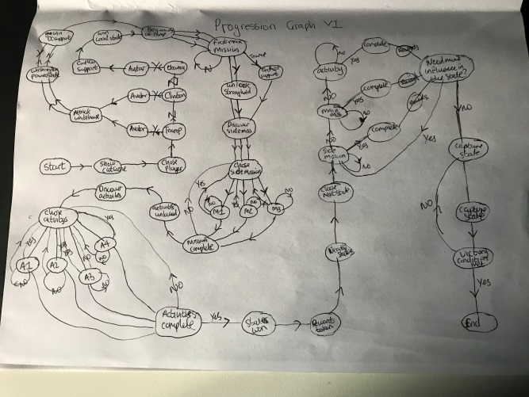To create my progression chart I used my storyline at the time as a guide, what events might occur during gameplay, there endgames and potential DLC.

### First Iteration:

In my first version of the progression chart I concentrated on the content towards the storyline over the layout and neatness. I used an A4 piece of plain white paper. I followed the gameplay plan updated from the interim project presentation, as a result the main actions towards gameplay and player choice are represented in the chart with the option “yes” and “no” having immediate effects. This shown on figure ()

### Second Iteration:

In my second version I included the downloadable content (DLC) options the player will have available to purchase and where they can use what they have bought. For example DLC characters, customisations, missions and scenarios. Also the main actions on the chart are related to what they stand for such as circle is a process and multiple boxes mean multiple choices for the player. This is shown on figure ()

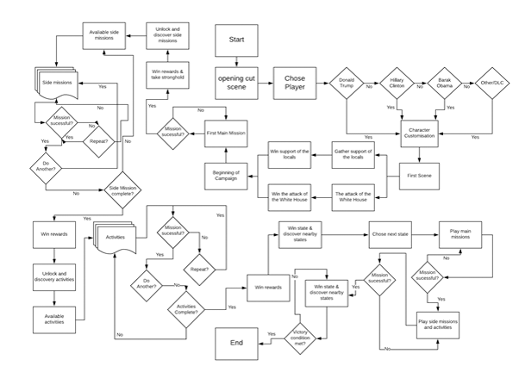

### Third Iteration:

In my third iteration I used a chart creating company online called “Lucidchart” **(Link 12)** to make my progression chart using my drafts on paper. This site allowed me to make every action the player has to be represented correctly. These include a square for a process, diamond for a question and multiple squares back to back for multiple choices. This is shown on figure ()

### Fourth Iteration:

Once I created my chart using “Lucidchart” I noticed it was very crowded and somewhat hard to follow. I discovered “Microsoft Visio” and chose to recreate my chart on its system. This was a grave help due to the clear choices, representations and colours. I used the video icon for video scenes, a key with colours for the reader to follow and understand and also shortcuts to the chart so it doesn’t look crowded. This is shown on figure ()

# Game Icons:

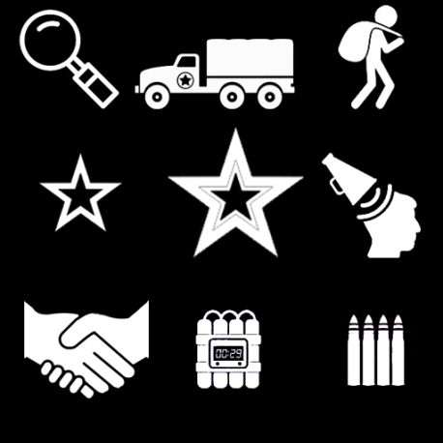Below are the games icons that will help the player know what missions and activities they’ll be doing and what rewards they can potentially earn for the completion of them.

### Mission & Activity:

These icons on figure () inform the player what missions, activities or main story mission they are setting to reach as well as an idea what they will be required to do. The first three icons represent discovery such as information gathering, hijacking an enemy convoy and looting abandoned areas. The following three represent side missions, main story missions and propaganda towards enemies and allies. The last three represent negotiations, timed explosive and ammo replenishment.

### Locations and character traits:

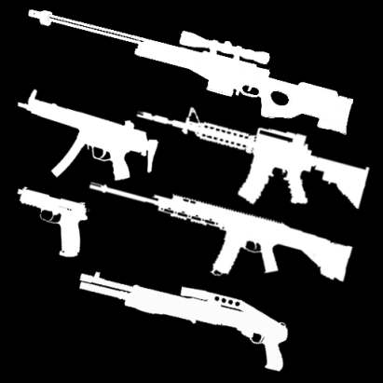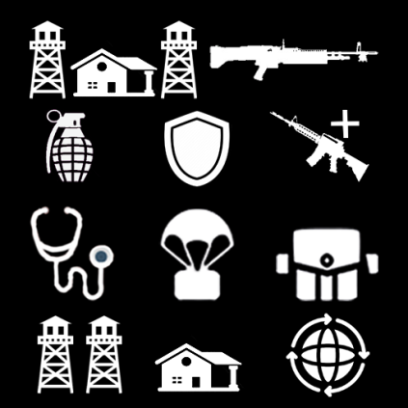These icons on figure () inform the player what locations of interest they might want to investigate as well as the actions or reward’s the character they have chosen can do complete or get. The top two represent a stronghold location and light machine guns which only Donald’s character can acquire. The next three represent explosives, armouries which only Clinton character can acquire and weapons base locations. The next three are Hospital location where the player can get more health; weapons air drops locations and appearance locations. The last three are fortified areas of interest, safe houses and international negotiations which only Obama has access too. These can be accessible for any characters through discovery and negotiations.

### Weapons:

These icons on figure () inform the player what type of weapons they have available to them on the weapon selection screens, mission rewards and loot able locations.

### Health Variations:

These icons on figure () show the options the player can use, upgrade and equip health. The first three on top represent health usage reloading, sharing health with allies and a loot able health kit. The next three represent acquiring more health packs, upgrading the effectiveness of health usage and adrenaline. The last three represent forging more health packs, drugs and injections.

### Inspiration

To create these logos I used the some of the designs from The Division 2 (link 13) and Wildlands (link 14) as well as some designs I created myself.

# Game Logos:

## Title Logos:

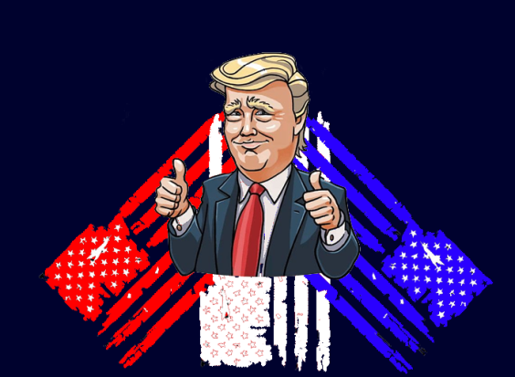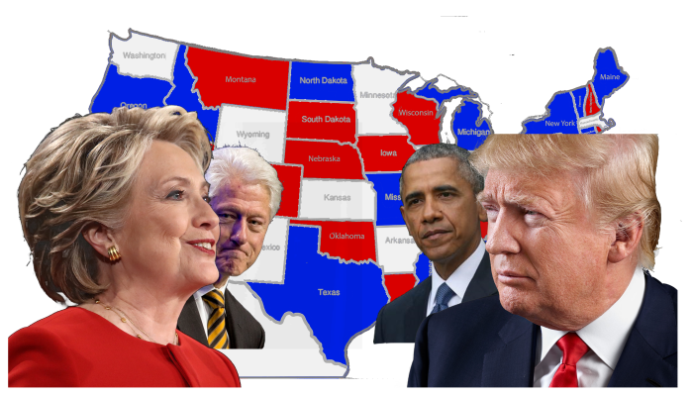On figure () is my game case and main menu logo for the console platform. It features all the main characters including Hillary (Link 15), Trump (Link 16), Obama (Link 17) and Bill Clinton (Link 18) having a face off amongst each other. In the centre of the logo shows a map of America and all its state names. Designing the map behind the Candidates will give the impression to any player with a console the impression of a battleground/ scene for power. The logo on figure () is my game logo for players who download the game off of the Apple or Android stores. It features Donald Trump with his Thumbs up (Link 19) and three American flags behind them. This is supposed to draw players who are into all kinds of mobile game. This is a work in progress.

## Faction Logos:

### Donald Trump

The faction logo on figure () will be representing Donald Trump’s faction. It shows himself on the front with his thumbs up (link 16). It has two American flags behind him; some of the state represented with a star is missing due to his acknowledgement of these states being relatively minor to him. His slogan “make America great again” is his 2016 election slogan campaign, this is to show that he thinks his ways are correct.

### Hillary Clinton:

This faction logo on figure () will be representing Hillary Clinton’s faction. On the front there’s a photo of Hillary holding a pistol and aiming straight towards her enemies (link 20), whist Bill is hidden behind her. This is supposed to install fear into her enemies through intimidation. Her slogan “keep calm it’s my turn” refers to her allies to tell them whatever happens she will take power from Trump.

### Barack Obama:

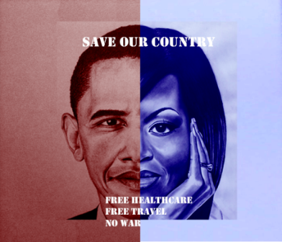The faction logo on figure () will be representing Barack Obama’s faction. In the centre of the flag shows an image of Barack and his wife Michelle split half and half with one side being shaded red and the other blue. This is supposed to represent equality amongst gender and colour. This title slogan “Save our Country” is supposed to appeal to the public who have suffered and wish to stop there country being destroyed due to politics. His secondary slogans show what he plans to do after the war is over.

# Game Map and Features

## Map

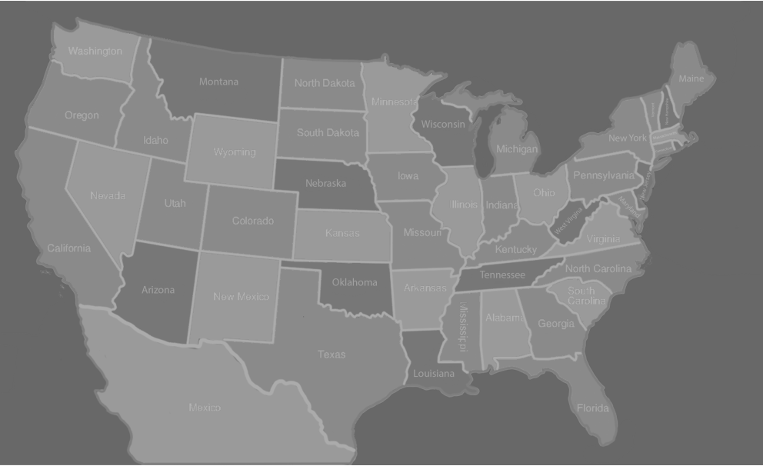This game map is where the player will always be located during gameplay (Link 21). They will have to navigate their way around America coming missions and activities to progress. He player cannot get into the next city or state on their agenda until they have successfully completed the main story missions. The player cannot access Mexico unless they are Donald Trump and chose the escape option in his storyline. This is shown below on figure ().

## City Representation

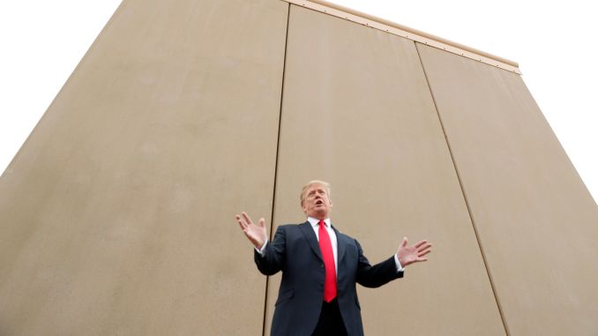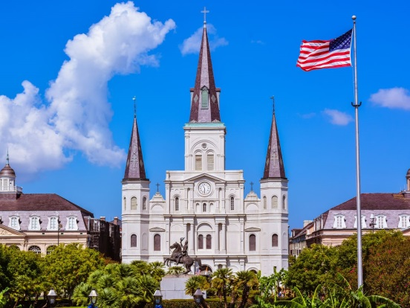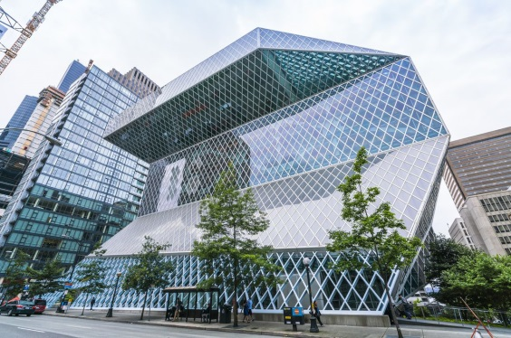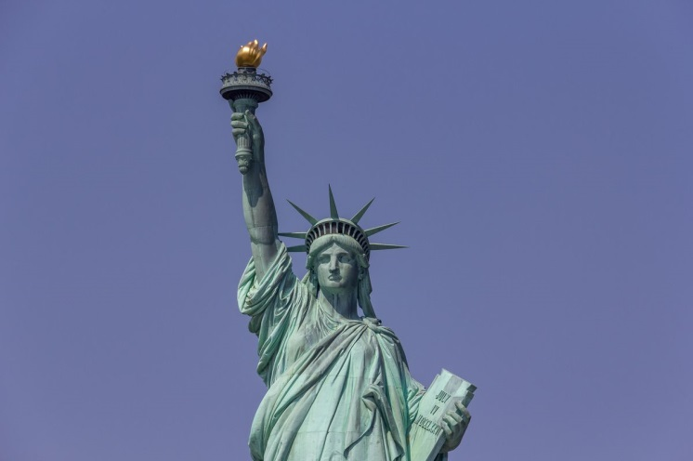On the game map there are also cities where the player can complete side and activities in order to capture and win its rewards. These cities give a major boost to the influence requirements in its state so the player can progress and win the rewards on offer. The cities the player will be able to see are the capitals of each state as well as any cities with any iconic landmarks (Link 22) or owned buildings by the character (link 23) such as the trump towers. Examples are shown in figures ()

# Artefact:

As part of this module I am required to provide a playable prototype of the game as well as any created or downloaded assets used. The diagrams, storyline and storyboards must be used as a guide to create the game using the preferred software and game engine to present my game design as well as provide video footage of the player playing.

Below are all the clothing artefacts created using Autodesk Maya 2019 whist using video guides as well as my own skills using reference images. These models will then be imported into a game engine and included in the character customisation screen so the player can select the item and include it on their character they’ve selected. There are also models downloaded from 3D model sites such as SketchFab and Turbosquid to help fill in the options unable to be completed manually.

### Head & Face Customisation

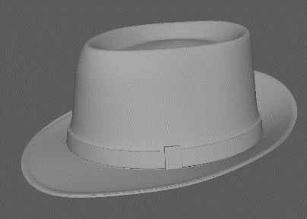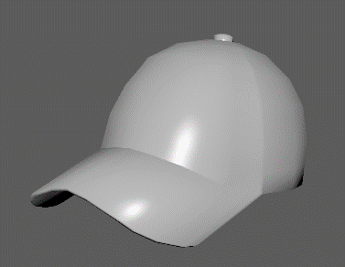In the game there are my head model assets such as a variation of hats the player can select in the customisation menu. The asset was created on Autodesk Maya 2019 using the methods of extruding, scale, connect, soft selection and smoothing tools. Using these given tools, the models created where a cap/ snapback, tweed hat, brim hat and a felt hat. These are shown on the GIF links below. I used reference images with rotation options, guild line videos and photos taken by myself to create these assets. For the cap (KG, A 2020) and felt hat (link 25) and video (link 27) I used a rotatable references as a guide, the brim hat (link 26) I used static images and finally I used my own tweed hat as a reference to complete these models. Examples on figures () and the first GIF link shows these models.

### Face Customisation

The next category of assets are my face models, specifically different variation of glasses the player has access to in the customisation screen. They were created using the same tools as the hats as well as being smoothed in certain sections rather than the whole object, but with the addition of using the mirror tool to save time, avoid illegal polys and being perfectly symmetric.

I used a variety of different guide videos and reference images to complete these models, the first pair was created using (link 28) images, the second using (link 29), the third using (link 30) and the last using (link 31) and then adding several holes in the middle. Examples are shown below in figures () and the second GIF link shows these models.

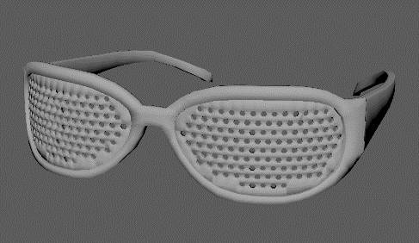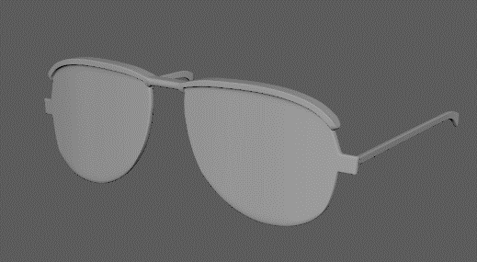

### Upper & lower body customisation

The next category of assets are my upper and lower models which the player has access to in the customisation screen. They were created using the same tools previously specified but this time using the soft selection tool and curving a lot of the hard edges in order to add fabric creases and folds to the models. Examples are shown below of figures () and the third GIF link shows them all.

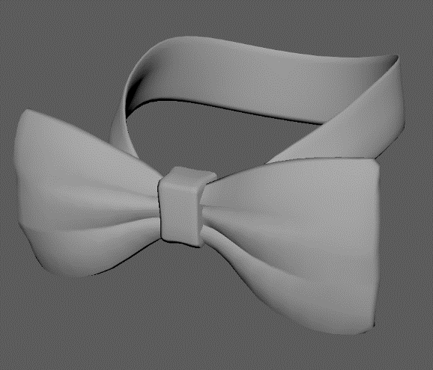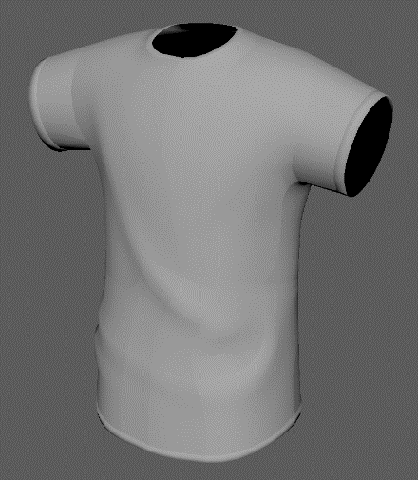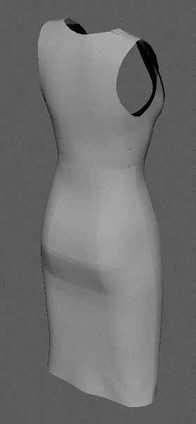I used a variety of videos to help guide me along the process of these models, however some models proved to be to challenging for me so some of the models where downloaded from Sketchfab and Turbosquid online free 3D models library to help fill in the models required. These included shirts (link 32), jumpers (link 33), dresses (link 34, 35) and trousers (link 36). The fourth GIF will show them all.

### Footwear Customisation

My last category of assets are the footwear models which the player will have access to in the customisation menu. They were created using all the previous methods and tools previously stated as well as the mirror and bridge tools in order to keep things symmetric. I used some models downloaded off the internet and took the footwear from those models, I then edited these models by reducing the amount of faces as well as parts from previous models being implemented. I used free 3D model websites such as Sketchfab to help me create these models as well as receive footwear models to save time (Link 37) Examples are shown on figured () and the fifth GIF link shows all my current models.

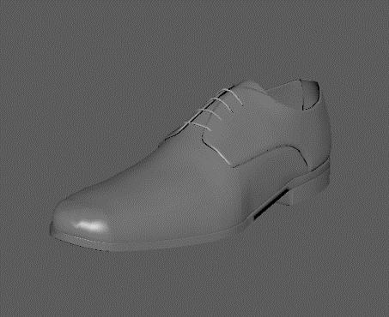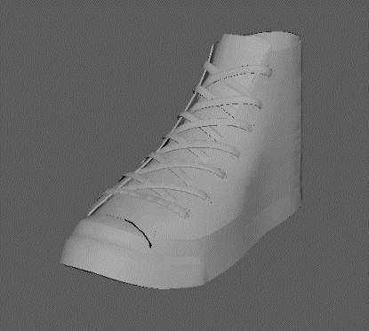

## Characters

For the game I am required to create playable characters (PC’s) and non-playable characters (NPC’s) for the player to choose, customise and interact with or against opposing NPC’s. To create these characters with a realistic style would prove to be a major challenge.

Adobe Fuse Development

Whist researching into methods to create realistic characters I came across a video (link 38) explaining an app called Fuse created by Adobe which lets the user build realistic characters with a vast amount of options towards customisation.

The user will have to assemble the character using the given options of head, torso, arm and legs. They then have the options to customise these body segments as well as the characters teeth and facial features. Then these the clothing options, the software has a lot of default options but the user can import their own 3D creations to use towards customisation. Lastly there’s the options to change the colours and patterns on these clothing assets.

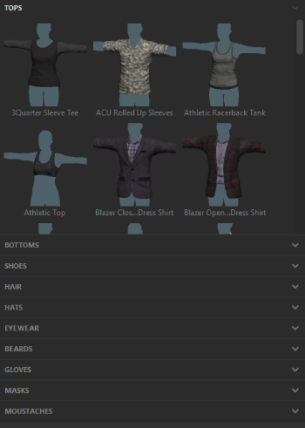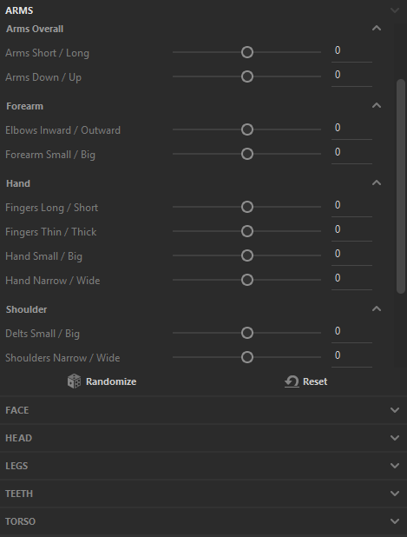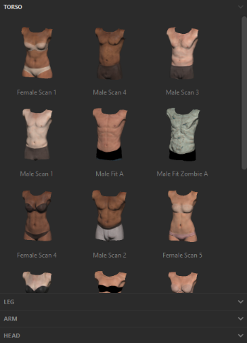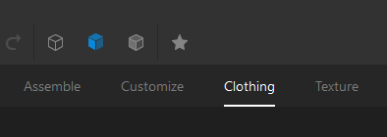Below on figures () shows all these options and sub-options the user have available to them and on figures () shows a few characters the users can create using the default settings of all sections.

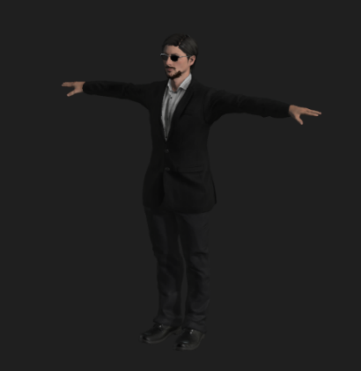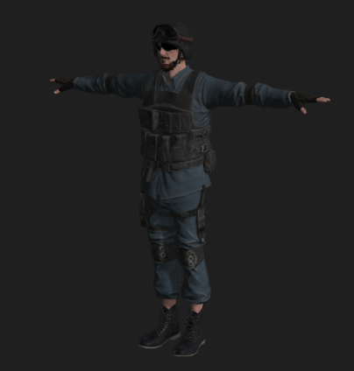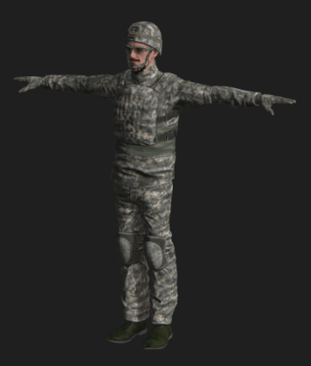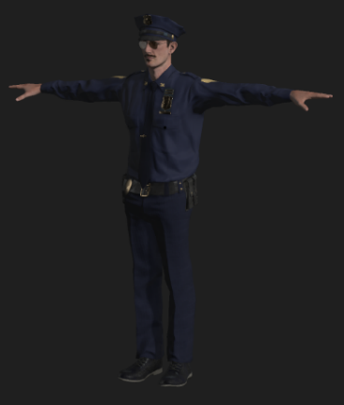

### GIF links to Models

<https://media.giphy.com/media/VEVSd6u6W72EZqqzcs/giphy.gif>

<https://media.giphy.com/media/LnLW06jY0YrHGIi00E/giphy.gif>

<https://media.giphy.com/media/VJrt7kVjPHo6t8a48R/giphy.gif>

<https://media.giphy.com/media/cM3Ddd3IvXeHg7tTbu/giphy.gif>

<https://media.giphy.com/media/ZFK3W7PapdnG32AW17/giphy.gif>

## Prototype

### Character Customisation

* Creating PC’s characters

### Clothing Customisation

* Including created assets into clothing library’s

# Future Development

### Create variation icons:

For the player I have only created HUD icons relating to the usage of health and the distribution of it. What I wish to do is create player HUD icons for the use of weapons such as ammo and reloading icons, armour effectiveness or health, different types of explosives such as C4 and TNT the player can select to use and lastly negotiation icons where responses will be related to the responses, replies and consequences towards both the player and the group in negotiations.

### Create city landmark locations:

Currently on the game campaign map there’s no indication on where state capitals and iconic building areas/ cities are placed, due to this issue the player cannot win the support from these areas making gameplay limited to just states. I will be creating these city capitals by placing small distinct areas on the map and labelling it with a filled in white star, this will help indicate this is the state capital. For the iconic buildings they will be placed in a 2.5D form on the map within each state or city depending on where they are located.

### Logo Iterations

For the main console case title logo, the feedback I received is it looks too much like an election campaign logo rather than a civil war, destructive and power taking role playing game logo. To create an excellent, memorable and appropriate logo design I will be looking into logo methodology (link 39), how to create a games logo which is unique and not standard or boring (link 40). With this new knowledge I will be watching video guides on logo creation techniques (link 41) I could use to create my own.

### More customisation options

I will also look into and create more 3D clothing, accessories and variation models to add to my current library of models the player can chose from. The current options available to the player are minimal resulting in reduced character customisation for the player. I will try to include accessories such as earrings, suitcases and backpacks which the player can select multiple models to choose from. This allows the player to customise more than just the clothing of their character. I will try to adding selections of colours, textures and patterns towards the clothing and accessory items, resulting in more options for the player to choose from.

### Game engine menu screens

I will also implement the character customisation options create on Adobe Fuse onto Epic Games Unreal 4 game engine with the main menu and character selection screens required to reach the customisation screen. I will be using video guide such as (link 42) to remind me of menu creation and (link 43) to help me create the customisation screen for the player.

### Introductory Levels

I will also create the first introductory level for all three playable characters being Trump, Clinton and Obama. Trump and Clinton’s first level will be at the White House. The player selecting Donald will defending his house whist learning all the basic mechanics required to progress through to the game map. Clintons character select will start as a militia soldier attacking the white house whist learning all the mechanics and Obama will be gathering influence and support in his local state learning his negotiation supremacy towards allied and enemy forces.

# Outcome

* Complete 3d models which can be used
* Character creation skills from fuse
* Story telling skills
* Reaction from fellow students and lecturers
* Very short what I wanted to achieve with my prototype
* what’ve liked and didn’t like, what I wished I could have done

# Conclusion

* What I have learned/ reflection of process
* How to use Autodesk Maya more effectively
* Where I can get detailed models to use
* How to use adobe fuse
* How to use Visio to create charts effectively.

# References

1. <https://www.nicolelazzaro.com/the4-keys-to-fun/>
2. <https://www.monash.edu/rlo/assignment-samples/engineering/eng-writing-technical-reports/introduction>
3. <http://www.cyningstan.com/game/221/hnefatafl>
4. <https://healthy.uwaterloo.ca/museum/VirtualExhibits/Vikings/Tafl/viking/index.html>
5. <https://www.nytimes.com/interactive/2016/us/elections/2016-presidential-candidates.html>
6. <https://www.gamespew.com/2019/02/the-division-2s-new-scenery-is-enough-to-draw-me-back-in/>
7. <https://www.scholarlygamers.com/news/2018/10/10/farming-simulator-19-developer-blog-character-customization/>
8. <https://www.meme-arsenal.com/en/create/template/27675>
9. <https://www.youtube.com/watch?v=nKTT0cYybkc>
10. <https://www.youtube.com/watch?v=wvhBG-cSQKU>
11. <https://www.youtube.com/watch?v=_IJQITAnMdg>
12. <https://www.lucidchart.com/users/login>
13. <https://www.saracheung.com/?p=403>
14. <https://imgur.com/r/GhostRecon/D9Dh2kv>
15. <https://time.com/4519718/donald-trump-hillary-clinton-change/>
16. <https://time.com/time-person-of-the-year-2015-runner-up-donald-trump/>
17. <https://edition.cnn.com/politics/live-news/impeachment-inquiry-12-17-2019/h_76b39dda6a6678af6d1c6f09a76ea359>
18. <https://www.mic.com/articles/122391/bill-clinton-admits-he-made-one-huge-mistake-during-his-presidency>
19. <https://favpng.com/png_view/united-states-telegram-united-states-donald-trump-sticker-illustrator-png/GyY197fs>
20. <https://www.rollingstone.com/culture/culture-news/meet-the-controversial-artist-who-creates-surreal-paintings-of-hillary-clinton-33450/>
21. <https://www.mhpbooks.com/the-onion-most-read-news-source-in-minnesota-wisconsin-and-new-mexico/>
22. <https://www.curbed.com/2017/11/15/16656780/best-architecture-united-states-cities>
23. <https://www.esquire.com/news-politics/politics/a26965814/trump-tower-chicago-retail-failure/>
24. KG, A. (2020). *Liberty Baseball Cap - 8,95 £*.Hatshopping Shop. Available at: <https://hatshopping.co.uk/Liberty-Baseball-Cap.html> [Accessed 5 Dec. 2019].
25. <https://www.jenniferouellette.com/winter-wonderland/3501-m44-mens-felt-hat-with-wide-brim.html>
26. <https://www.pinterest.co.uk/pin/343047696613659950/>
27. <https://www.youtube.com/watch?v=ACcqG9bkmRc>
28. <https://www.uberpanache.com/getting-the-black-tinge-on-your-eyes-worlds-most-expensive-sunglasses-e36db409>
29. <https://www.zumiez.com/ray-ban-clubmaster-black-and-gold-sunglasses.html>
30. <https://taylormorriseyewear.com/collections/the-zero/products/zero-c10>
31. <https://www.alibaba.com/product-detail/FDA-Certification-new-design-fashion-cheap_60323422473.html>
32. <https://sketchfab.com/3d-models/shirt-745d0d185b49405694ef4e16cf78e224>
33. <https://www.turbosquid.com/FullPreview/Index.cfm/ID/1109145>
34. <https://www.turbosquid.com/3d-models/free-max-mode-amy-0-female-character/454342>
35. <https://www.turbosquid.com/3d-models/dress-lace-female-mannequin-3d-3ds/841802>
36. <https://sketchfab.com/3d-models/jeans-thic-7aba73c660a744f193388a9288deb859>
37. <https://sketchfab.com/demoon/collections/ref_shoe>
38. <https://www.youtube.com/watch?v=FrPjNYk_JQ0>
39. <https://blog.hubspot.com/marketing/creating-logos-design-process>
40. <https://www.gamasutra.com/blogs/JamesCavin/20180214/314636/Making_a_videogame_cover_that_doesnt_suck.php>
41. <https://www.lynda.com/Illustrator-tutorials/Logo-Design-Techniques/173877-2.html>
42. <https://www.youtube.com/watch?v=U_DY1lmHbLc>
43. <https://www.youtube.com/watch?v=GssYZCJwbSg&t=277s>